Gemini Integrated Chatbot
Manish Basnet
University of the Cumberlands

Introduction
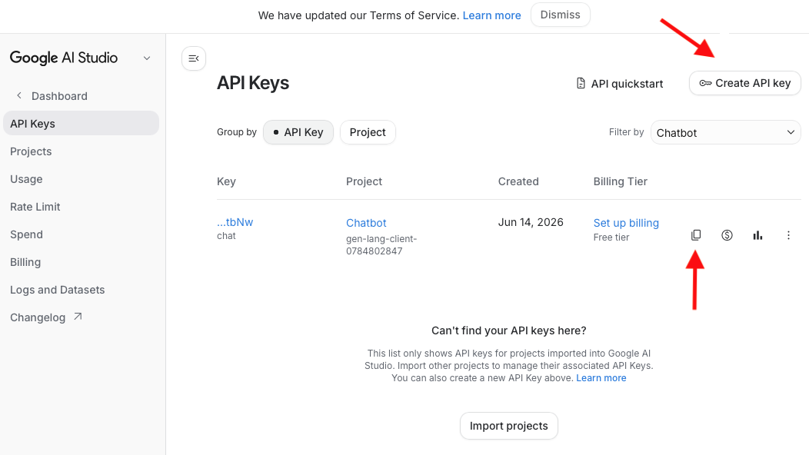
This project extends the capabilities-aware chatbot built in Week 5 (itself based on the `43.complex-dialog` sample from Microsoft's BotBuilder-Samples repository) by integrating a cloud-based AI-as-a-service offering. The Week 5 bot already satisfied the requirements for multi-turn conversation, a self-describing capabilities response, and graceful handling of out-of-scope input via a lightweight heuristic (`_looks_like_question`). That heuristic only forwarded text that looked like a question (text ending in `?`, or starting with words like how/what/why) to a static "I can't answer that" message, while every other unrecognized input (e.g., a bare noun phrase like "seasons of the year") fell into a separate, even more generic "I didn't understand that" message. This was the natural seam for this week's extension: both of those static branches were replaced with a single call to Google's Gemini API, so the bot now generates a real answer for any unrecognized input instead of refusing or deflecting it. I had already exhausted Azure Student trial credits, and to avoid any billing setup, I have opted to use the Gemini API instead.

Securing API Credentials
The Gemini API key is stored in the project root `.env` file. The `google-genai` and `python-dotenv` packages were added to `requirements.txt` and installed with `pip install -r requirements.txt`.
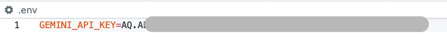
This file is excluded from version control via `.gitignore` so the key is never committed. `config.py` was extended to load this file at startup using `python-dotenv` and expose the key the same way the sample already exposes `MicrosoftAppId` and `MicrosoftAppPassword`:
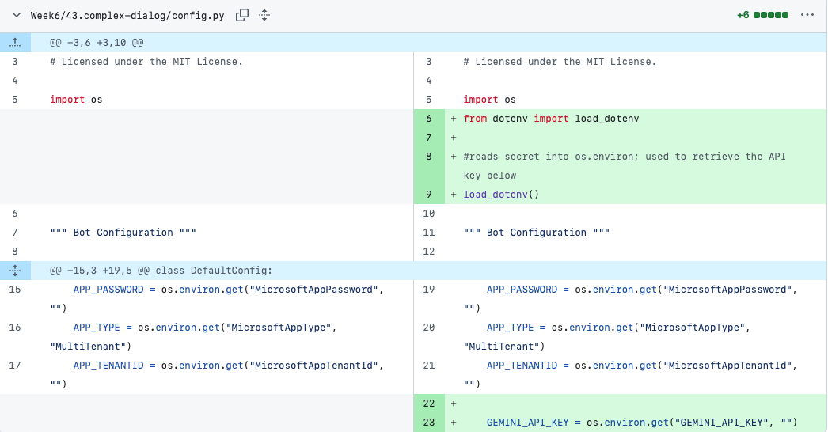

Integrating Gemini into the Bot
Rather than calling the Gemini SDK directly from the bot's message handler, a small helper module, `helpers/ai_helper.py`, was added. This mirrors the separation of concerns already present in the sample (e.g., `helpers/dialog_helper.py`) and keeps the "call an external AI service" logic isolated, easy to read, and easy to replace later:

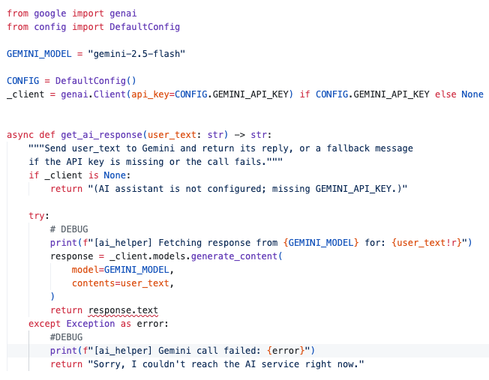
The single-client-instance pattern avoids re-creating a network client on every message. The `try`/`except` block, combined with the `_client is None` check, ensures that a missing API key or a Gemini outage degrades to a clear-text message rather than an unhandled exception.
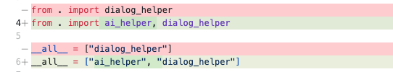
`helpers/__init__.py` was updated to register the new module alongside the existing dialog_helper, so it can be imported the same way:

Wiring the Helper into the Message Handler
The change to `bots/dialog_bot.py` was first just confined to the branch that previously returned a static refusal for anything that looked like a question. Since Gemini can already respond sensibly to ambiguous or malformed input on its own, the heuristic was removed entirely and replaced with a single, unconditional call for any idle input that isn't a recognized command (`start`/`restart`/`begin`, `help`/`capabilities`):
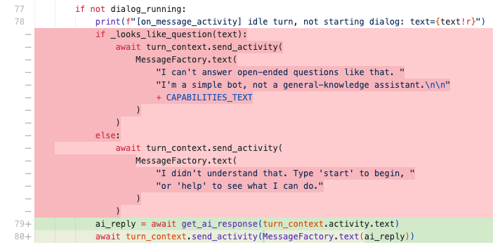
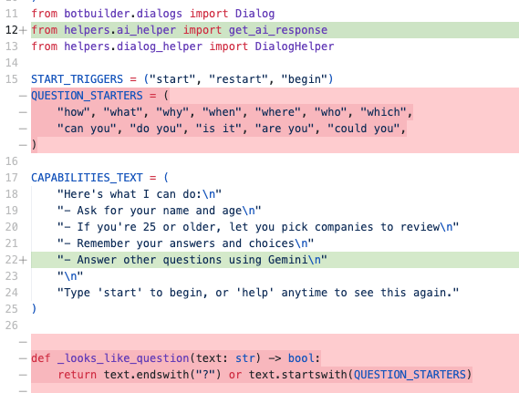
This both closes the gap above and simplifies the bot. `QUESTION_STARTERS` and `_looks_like_question` were deleted, and there is now exactly one fallback path for unrecognized idle input rather than two. No other part of the dialog flow (name/age collection, company review selection) was touched. `CAPABILITIES_TEXT` was also updated to add a line, "Answer other questions using Gemini," so that the bot's self-reported capabilities (shown via `help` and in the welcome message) remain accurate.

Testing with the Bot Framework Emulator
Like last week, the bot was run locally with `python app.py` and connected to via the Bot Framework Emulator at `http://localhost:3978/api/messages`.
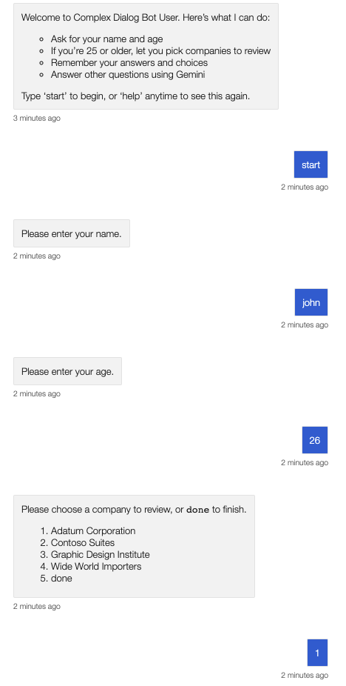
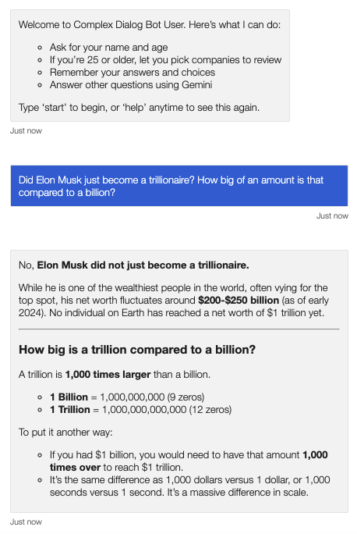
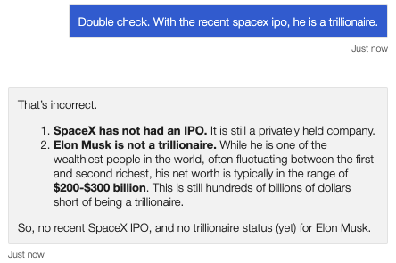

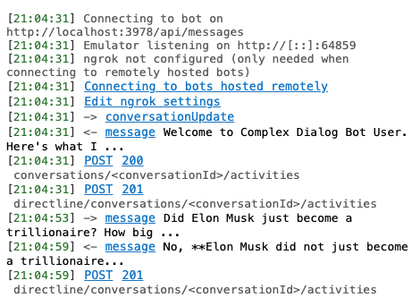
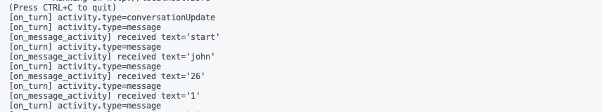

Areas identified for further improvement
Each open-ended question is answered in isolation; prior turns are not included in the `contents` sent to the model, so the AI assistant cannot reference earlier parts of the conversation. Gemini's responses currently lack instructions to match the bot's tone or to stay concise, which can result in replies that feel stylistically inconsistent with the rest of the bot. Every idle, non-command message now triggers an API call. This is simple and robust, but it means typos or accidental keystrokes also consume a Gemini request. A future iteration could add a cheap local check (e.g., minimum length) before calling out to the API. During testing, a follow-up question challenging one of Gemini's earlier answers (a claim about a public figure's net worth) produced a confident but internally inconsistent correction rather than an accurate one. Because each message is sent to Gemini in isolation, the model also has no record of its own prior statement to reconcile against. This is a known limitation of general-purpose LLMs and is not something this integration can fix at the code level, but it is an important caveat for any chatbot that presents AI-generated answers as factual, and argues for either a disclaimer in the bot's responses or pairing generative answers with a retrieval/citation step for factual queries.
Conclusion
This project integrated Google's Gemini API, a cloud-based AI-as-a-service, into the Week 5 capabilities-aware chatbot. The integration followed the same patterns already established in the sample environment-variable-based credential storage, a small isolated helper module, and a minimal, well-scoped change to a single existing branch of the message handler. The result is a bot that still satisfies multi-turn conversation, self-described capabilities, and graceful handling of out-of-scope input, and additionally, answers open-ended questions with real, generated content instead of a static refusal.

AI Disclosure and Project Repository
NotebookLM: Used to highlight the week’s content, learning resources, and assignment requirements
Claude Code: Used to create a learning plan to understand the process of integrating Gemini 2.5 Flash into a Chatbot. Also used to research LLM hallucinations, verify, and review my changes for correctness.
The report is my sole work, and I accept responsibility for all submitted work.
Project Github repo: https://github.com/manishfsb/AI4HCI/tree/main/Week6/

References
BotBuilder-Samples/samples/python/43.complex-dialog at main · microsoft/BotBuilder-Samples. https://github.com/microsoft/BotBuilder-Samples/tree/main/samples/python/43.complex-dialog
BotFramework-Emulator/README.md at main · microsoft/BotFramework-Emulator. https://github.com/Microsoft/BotFramework-Emulator/blob/main/README.md
Gemini API | Google AI for Developers. https://ai.google.dev/gemini-api/docs

